Relationship Assignment :

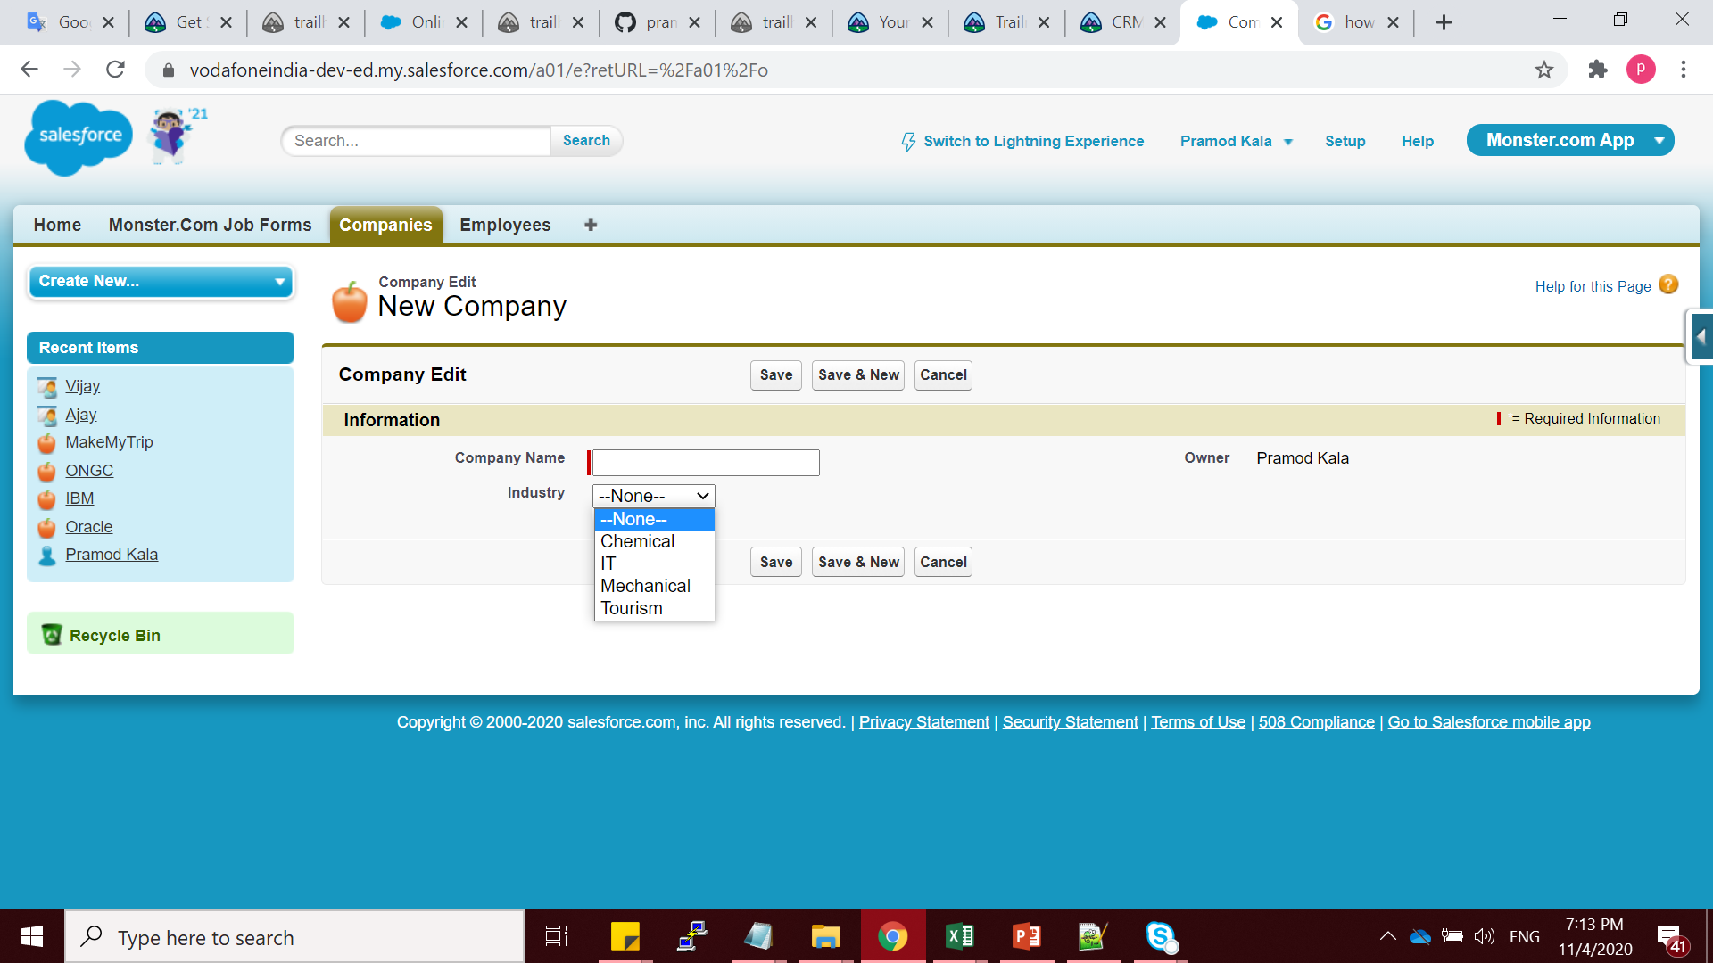

Look up Relationship on many side object i.e Employee

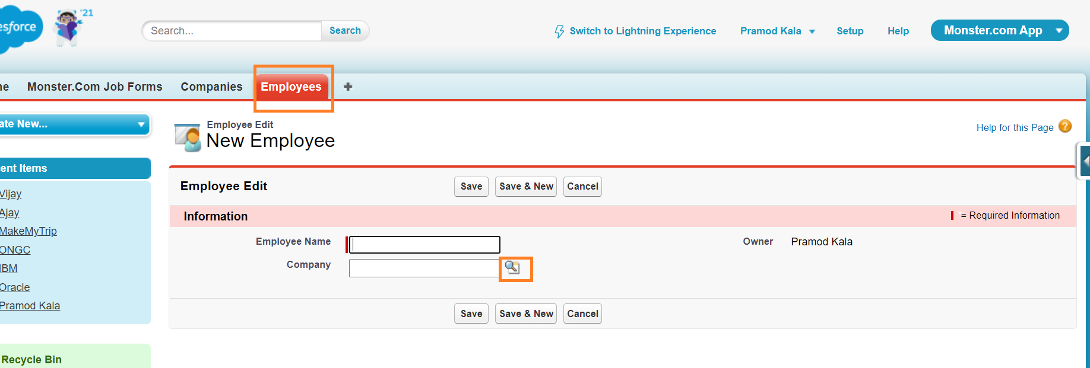

To get tourism as option we need to put filter clause on LR with value as Tourism

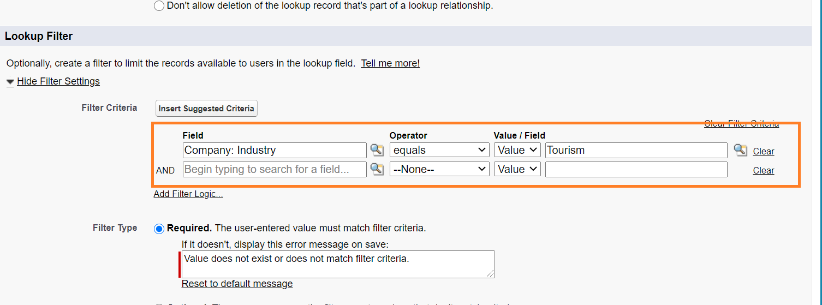

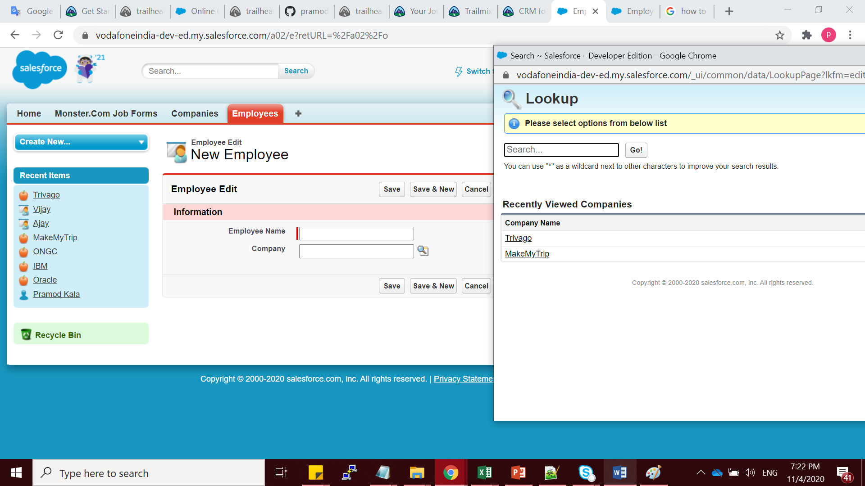

Label as Employee List for Company :

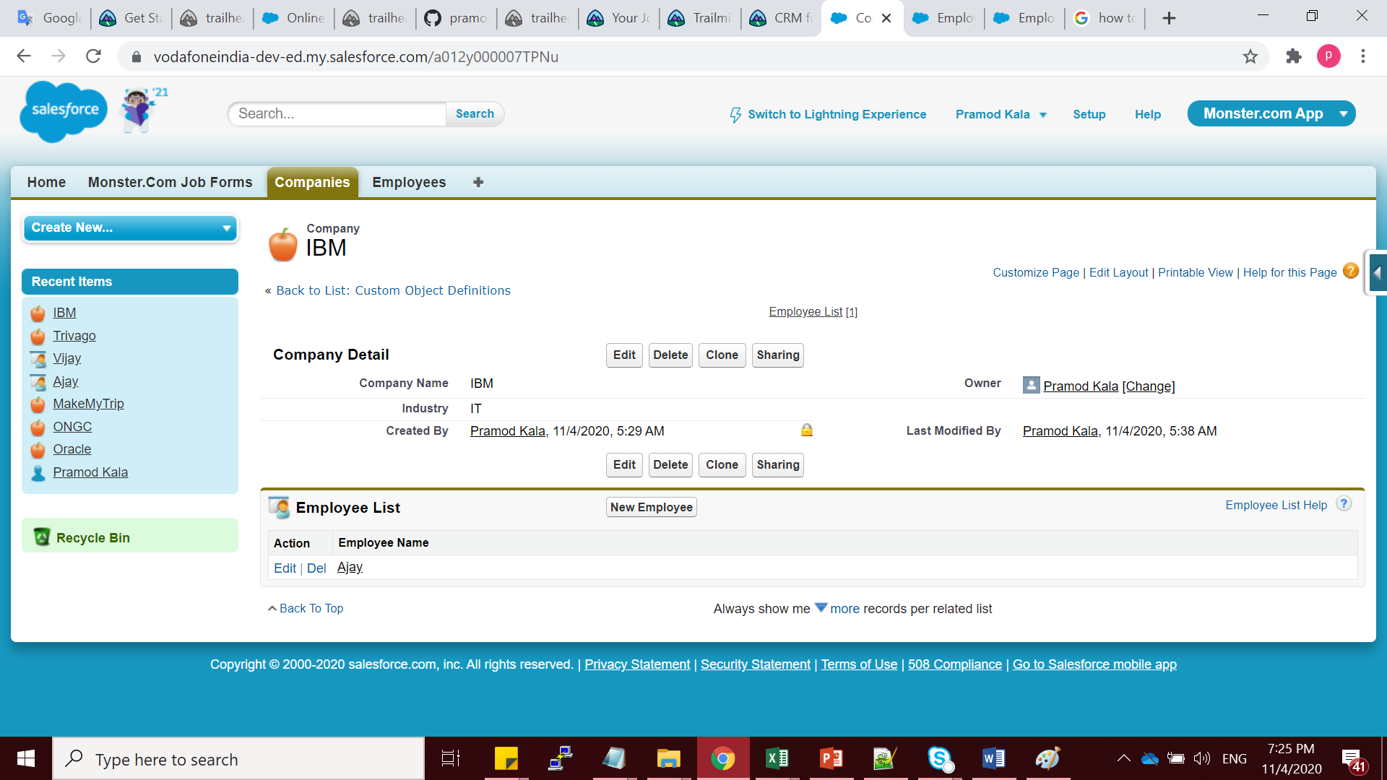

5 Need to select below option for not allowing to delete the company records for LR

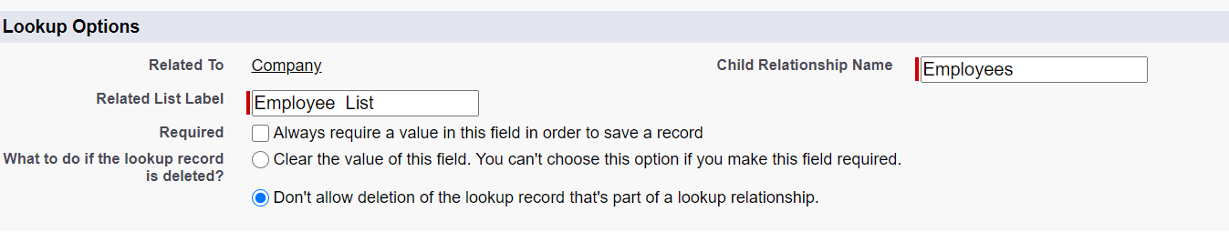

6 Detail of Company Record while hovering on Company name :

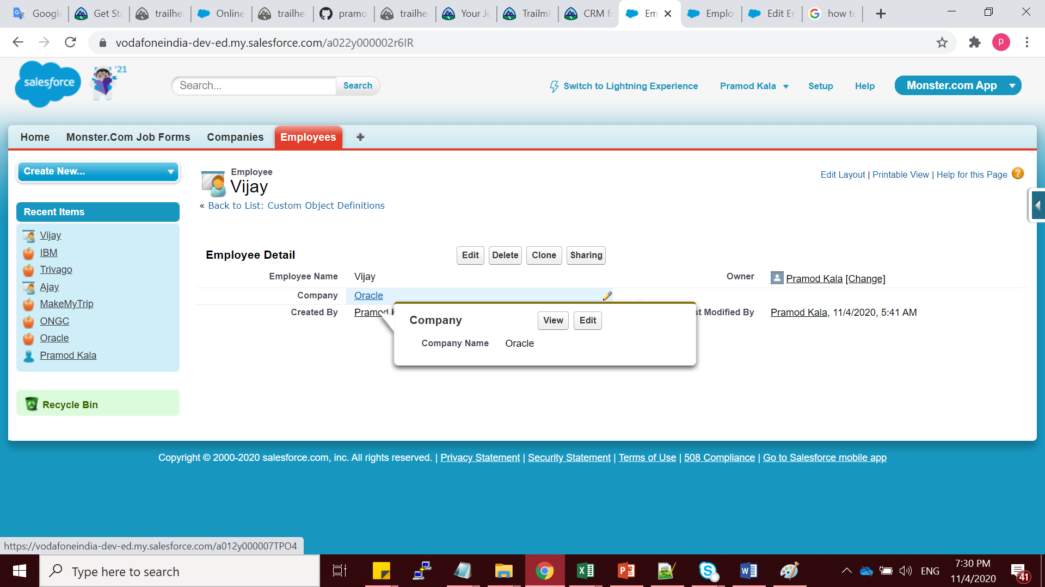

-------------------------------------MDR---------------------------------------------------------------

1. The relationship used is MDR as there should be dependency between the two and if we delete the taxpayer record then there is no use of keeping the associated Tax paid per month records.

2 We create the relationship on the many side object i.e the Tax paid per month. Primary object is Tax Payer Details.

3 We can create the Rollup summary field for each Tax payer to get the highest tax amount that is paid.

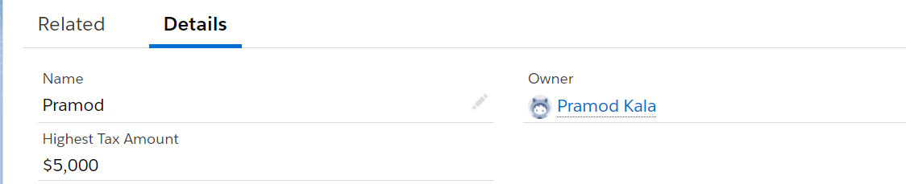

4

5 Used count Roll up summary field to get the number of times tax is paid by each tax payer. If required for specific year we can add a filter for Rollup on Field Year where value equals the year for which needs to be calculated.

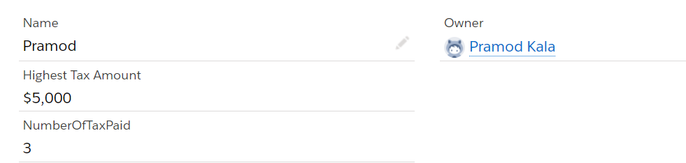

6 This can be achieved by reparenting the child object to another parent.

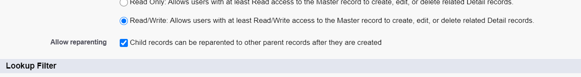

7 Avg : RollupSum / RollUpCount here 15000/4 =3750

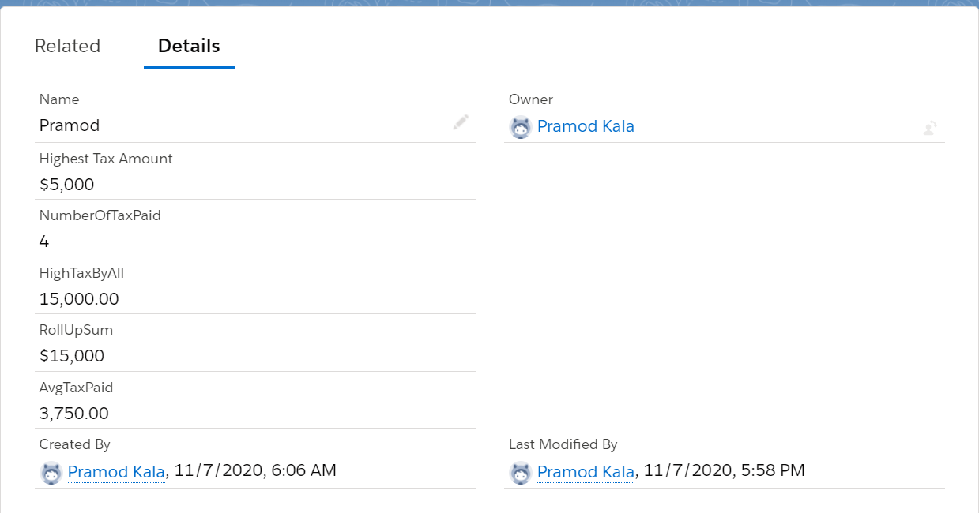

--------------------------------------Advance MDR-----------------------------------------

1 Created Vendor and Dealer Object.

Added records in Dealer Object

Created RL field on Dealer Obj

Assign a parent to each Dealer record

Changed the field type from RL to MDR

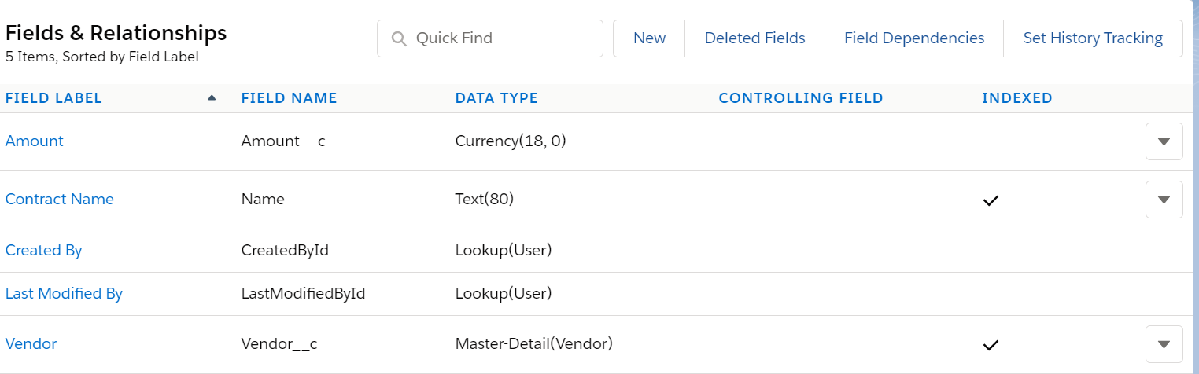

---------------------Many to Many----------------------

1 Created Project Object with Field as Project Name

2 Created Consultant Object with Field as Consultant Name

3 Created Project_Consultant Object (Junction Object) to implement many to many relationship between Project Object and Consultant Object.

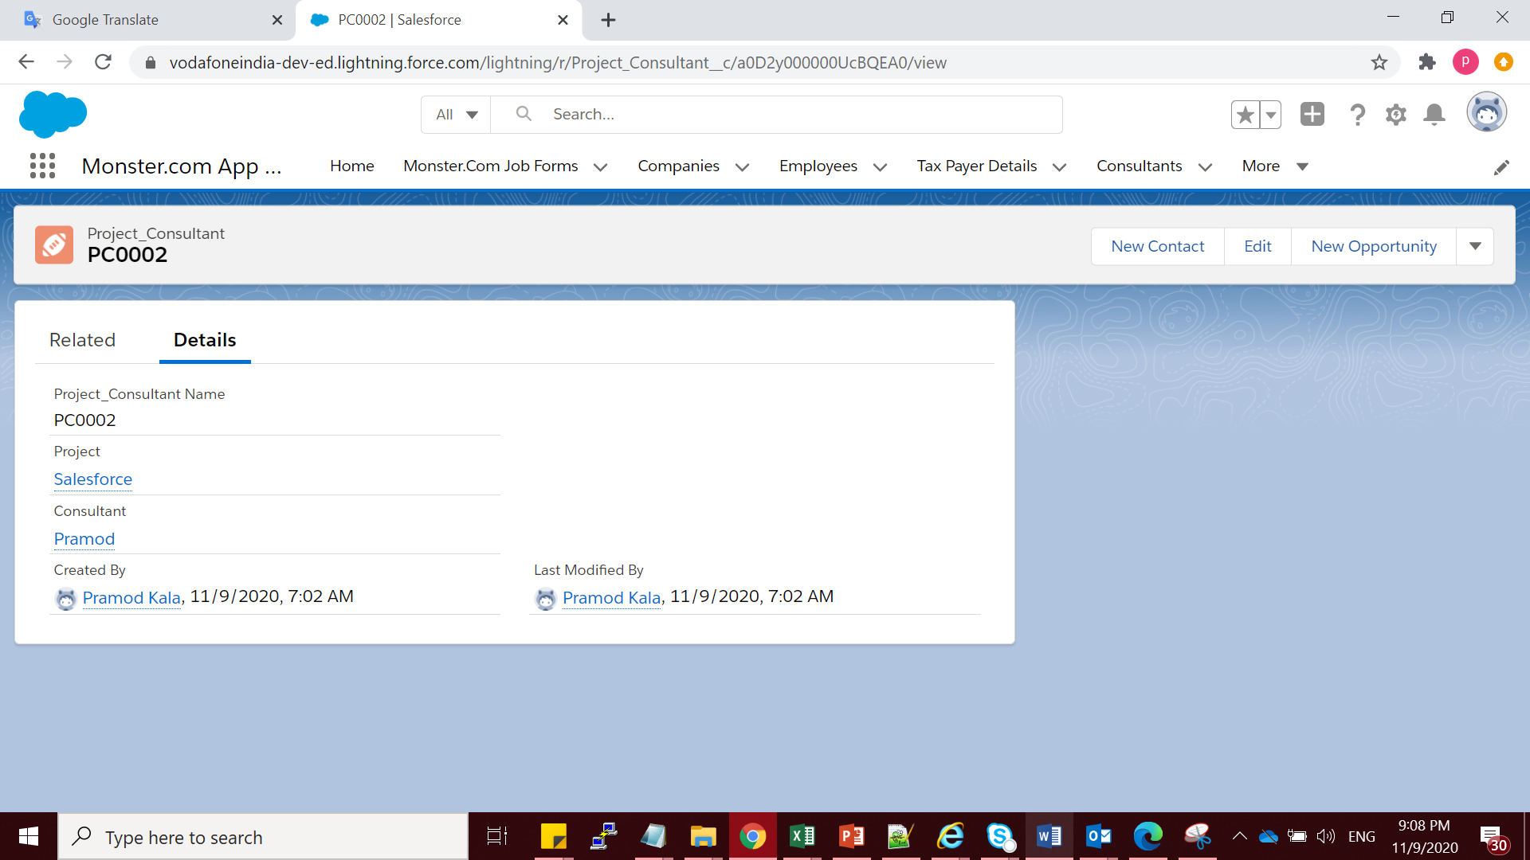

----Hierarchial Relationship-------

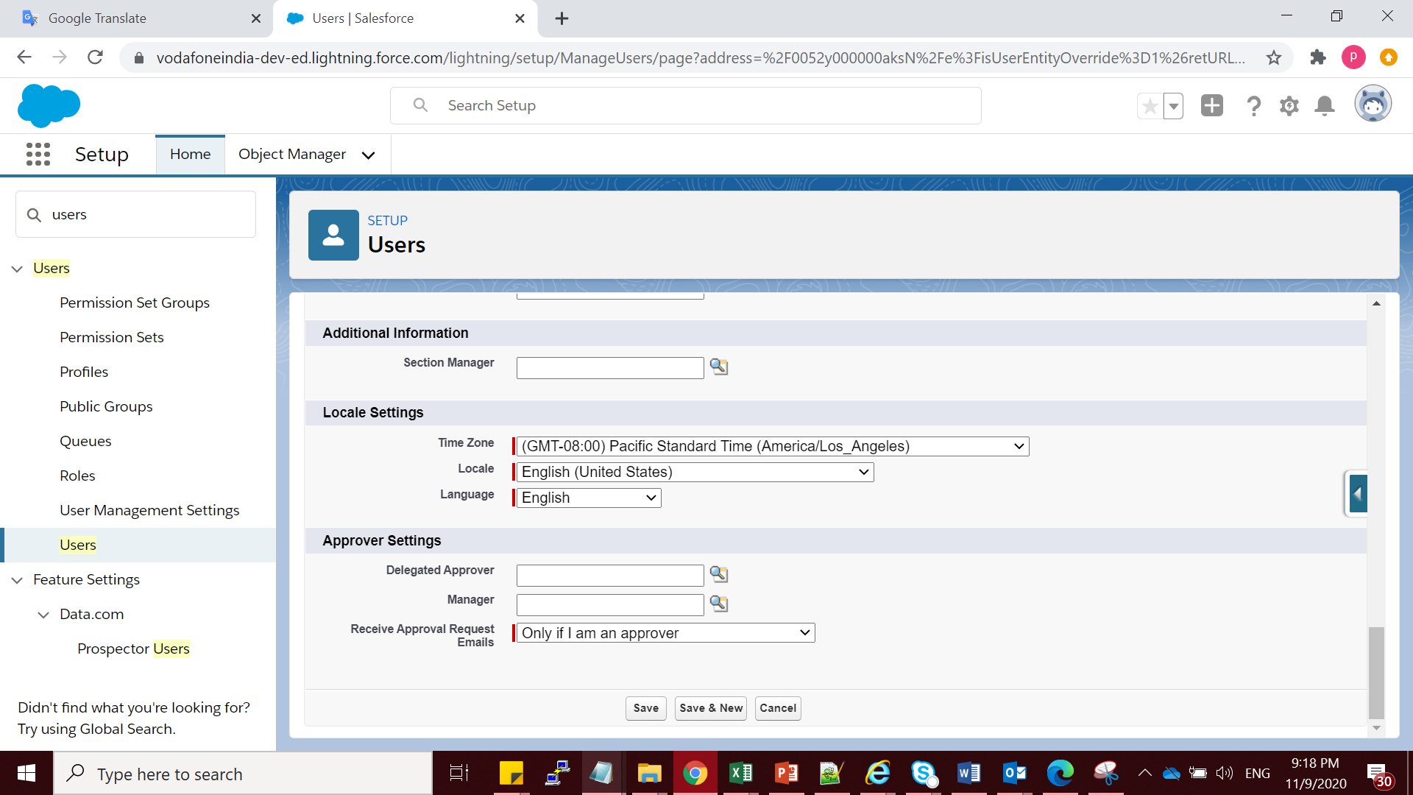

----------------------Self RelationShip-----------------

